|  |
| --- |
| **Overview** |

Practice using VS Code to create a p5js composition.

Save, zip, and upload your work to the appropriate myCourses dropbox.

|  |
| --- |
| **Landscape Requirements** |

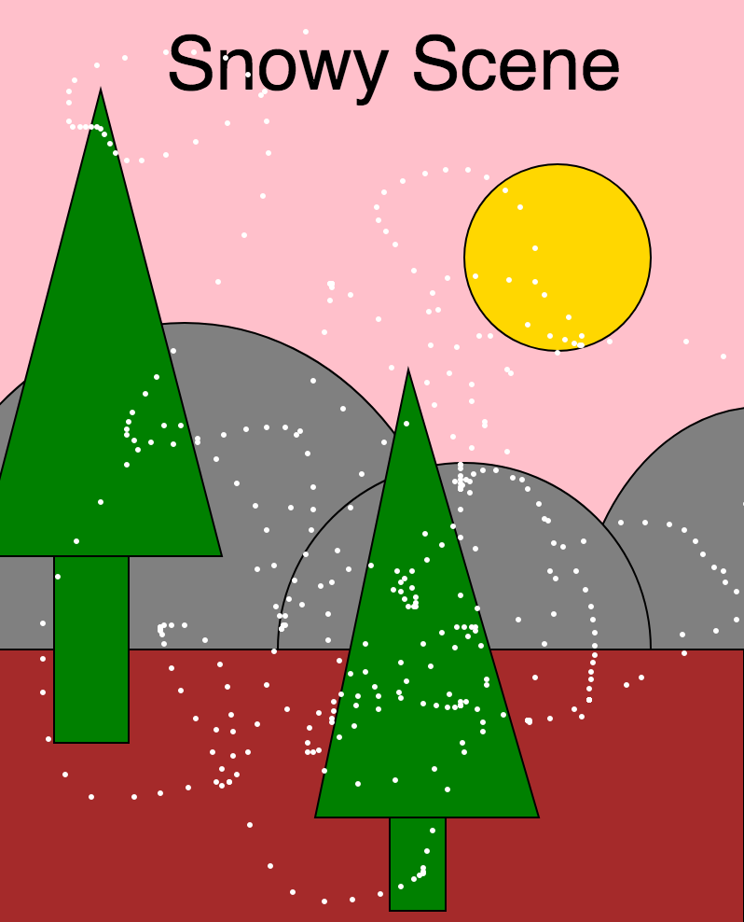

1. Canvas size is at least 400 x 400.
2. Incorporates at least 3 different types of shapes.
3. Incorporates at least 3 colors.
4. Uses at least one p5-variable to create interactive animation.
5. Uses the text() function to label the scene.
6. Code is commented with your name and notes about what is being drawn.

|  |
| --- |
| **Compress and Submit** |

1. In VS Code's Explorer panel, you can pop-up-click on your working folder (e.g. "CircleLineZzz") to reveal the folder in Windows File Explorer - "**Reveal in Explorer"**. You'll likely be in Documents/101ZzzSketches/.

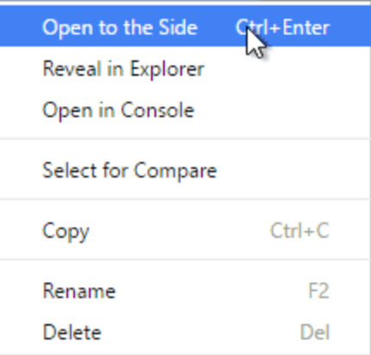

1. In the Windows File Explorer, pop-up-click on the folder name (e.g. "CircleLineZzz") and select "7-Zip :: **Add to CircleLineZzz.zip."** 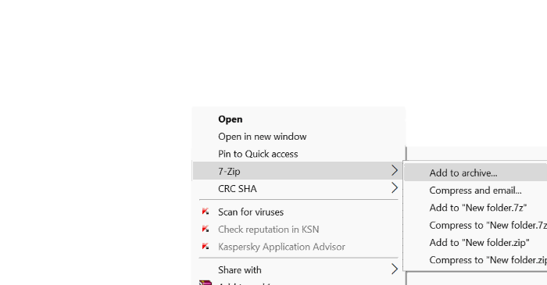
2. Submit this .zip file to the appropriate myCourses assignment dropbox by the due date.  
   <https://documentation.brightspace.com/EN/le/assignments/learner/submit_assignments.htm>